PROJECT DOCUMENTATION / FUNCTIONAL SYSTEM DESIGN (FSD) DOCUMENTATION

Functional System Design (FSD) Documentation
Implementation-oriented documentation for Incident Life Cycle Automation
DATE  07 October 2026 | STUDENT NAME  Gangadevi.R | PROJECT  Incident Life Cycle Automation

1. Introduction
Project Title: Incident Life Cycle Automation
Student Name: Gangadevi.R

2. Project Overview
Purpose: automate the flow of operational incidents from intake to closure while making ownership, priority, SLA state, notifications and audit history visible and consistent.
- Incident intake and unique identification
- Rule-based triage and assignment
- SLA monitoring and escalation
- Lifecycle status tracking and work notes
- Resolution and closure
- Search, dashboards and audit trail

3. Architecture
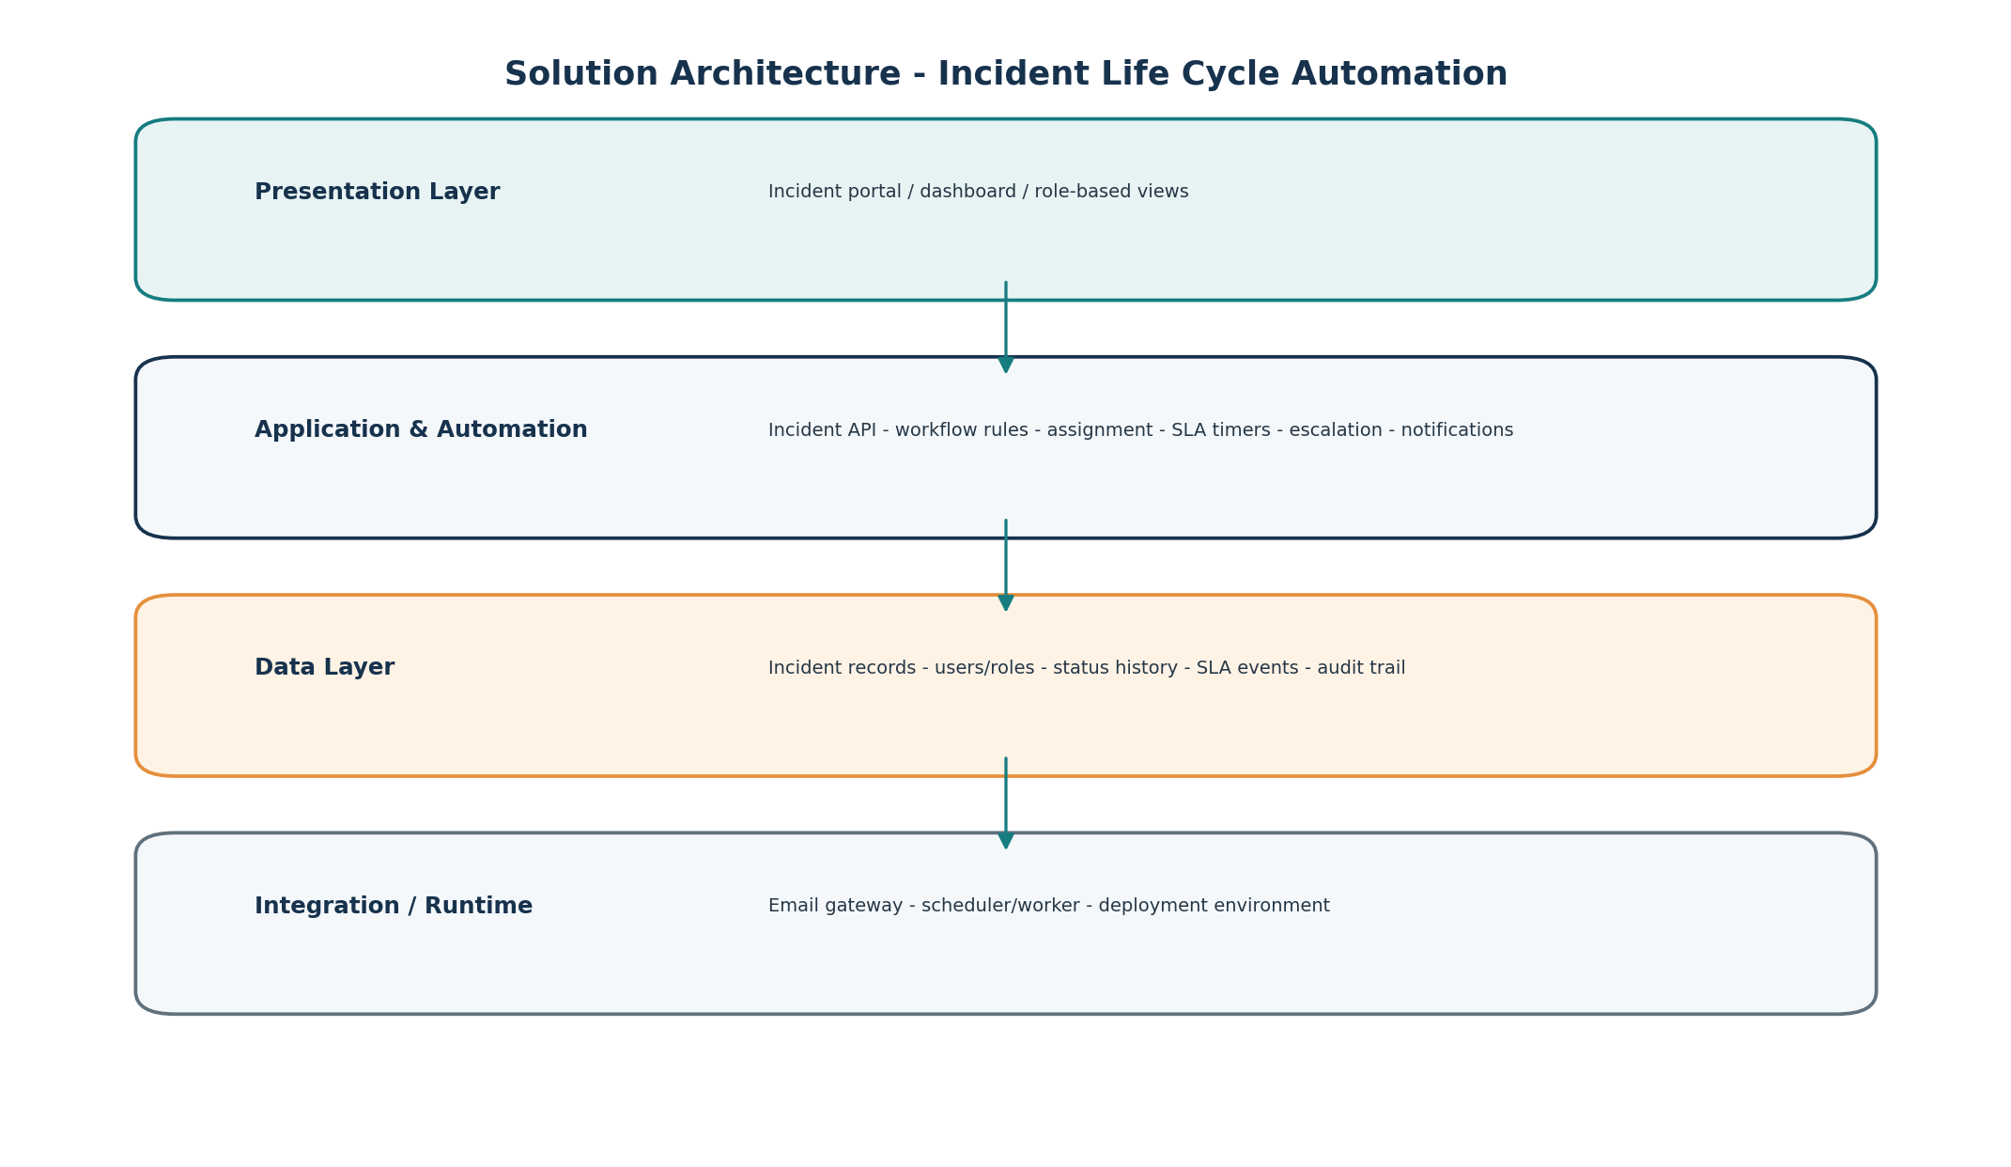

4. Data model (logical)
Entity | Key data | Relationship
Incident | Incident ID, title, description, source, category, impact, urgency, priority, status, owner, timestamps | Central record linked to users, history, SLA events and resolution.
User / Role | User ID, name, role, access scope | Controls who can view or modify incidents.
Status History | Incident ID, old status, new status, actor, timestamp, note | One-to-many with Incident.
SLA Event | Incident ID, due time, event type, triggered time, state | Tracks SLA and escalation lifecycle.
Audit Entry | Actor, action, entity, timestamp, context | Traceability for key changes.

5. API / Service responsibilities
Service | Purpose
Incident Service | Create, read, update and close incidents.
Triage Service | Apply classification and priority rules.
Assignment Service | Resolve queue/owner and manage reassignment.
SLA Worker | Check due times and emit escalation events.
Notification Service | Send assignment, status and SLA notifications.
Audit Service | Persist lifecycle and administrative history.

6. Testing
Functional testing should cover positive and negative flows; UAT validates user expectations; performance testing measures response and scheduled-job behavior using actual implementation results.

7. Known limitations
- Initial scope prioritizes core incident lifecycle automation and excludes unrelated features from the current build.
- Actual performance figures depend on the final deployment environment and dataset size.

8. Future enhancements
- Multiple SLA policies by service and priority
- Advanced analytics and trend reporting
- Integrations with enterprise ticketing / messaging tools

